**Design Document of Employee CRUD Application**

# **High-level architecture of Spring boot project.**

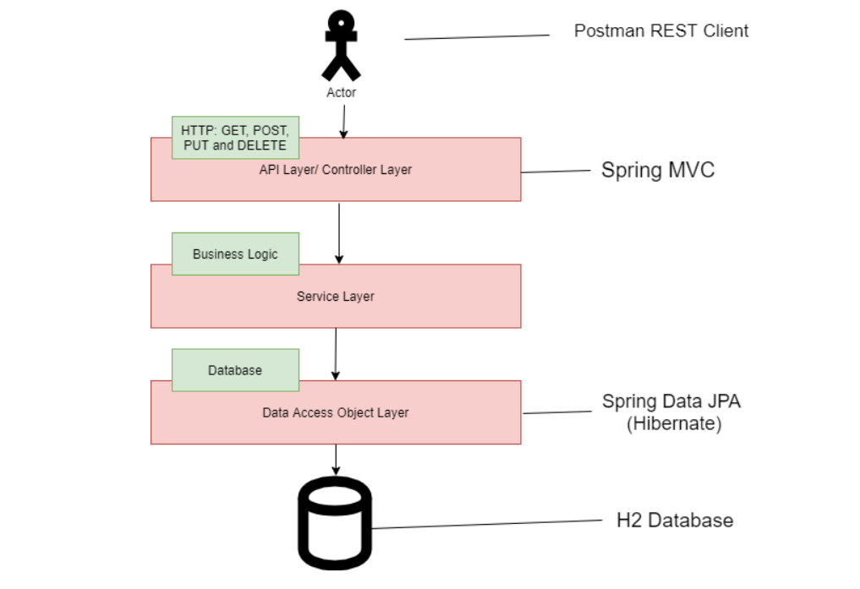

# **Spring Boot CRUD Rest APIs Development**

Here are the five REST endpoints that we developed.

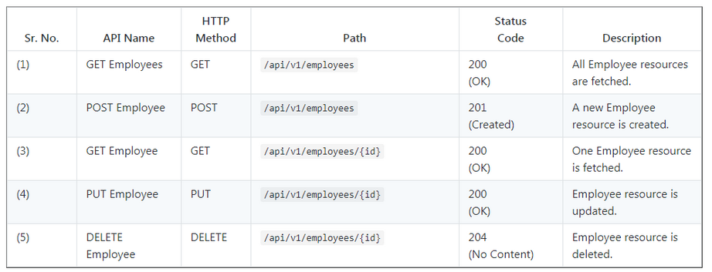

# 

# **Components, Services, and Modules**

Let's list out components, services, and modules that we are going to create in this application. We will use Angular CLI to generate components, services because Angular CLI follows best practices and saves much time.

### **Components**

* create-employee
* employee-list
* employee-details

### **Services**

* employee.service.ts - Service for Http Client methods

### **Modules**

* FormsModule
* HttpClientModule
* AppRoutingModule

### **Employee Class (Typescript class)**

* employee.ts: class Employee (employeId, firstName, lastName, email)

The below diagram summaries the Angular components that we are going to create going forward:

